You and your colleagues are invited …
Career Educators Association of the NT
Networking Event

Thursday 8 December
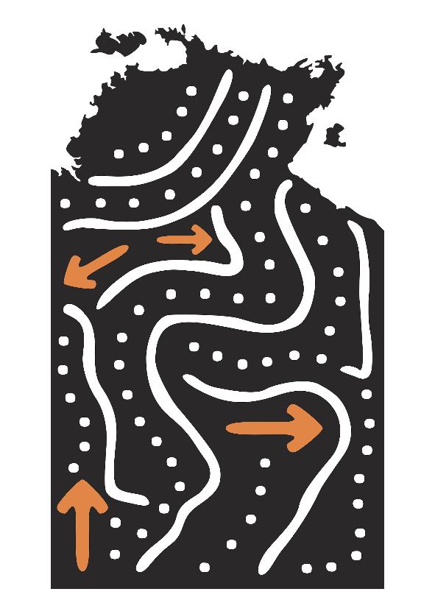
4pm -5.30pm
Guest Presenter Amy Hetherington
A comedian with terminal & contagious positivity
Youth Advocate, Marketing Consultant,
Graphic Designer, Film Maker and more …
Rydges Palmerston
Level 1 15 Maluka Dr, Palmerston

RSVP by 5 Dec at
info@ceant.com

